Alumni Records Web Application
M.Simic, Lj. Kazi, B. Radulovic, D. Glusac, M. Zakin, D. Milanov, Lj. Radovanovic, D. Karuovic, P.Pecev
University of Novi Sad, Technical faculty “Mihajlo Pupin”, Zrenjanin, Serbia
sima_pos@gmail.com, leremic@tfzr.uns.ac.rs, bradulov@tfzr.uns.ac.rs, gdragana@tfzr.uns.ac.rs, milazakin@yahoo.com, dusanka.milanov@gmail.com, ljiljap@tfzr.uns.ac.rs, aruena@tfzr.uns.ac.rs, predrag.pecev@gmail.com

Abstract – Alumni records is important for marketing of a higher education institution as well as for cooperation of the institution with former students that graduated at that educational institution. This paper presents a web application for alumni records representation. The application was developed at Technical Faculty “Mihajlo Pupin” in Zrenjanin, University of Novi Sad.

Introduction
Social networking is proved to have positive impact to health condition of individual [1]. In the world of information technologies, web based social networking tools are common in personal [2], educational [3, 4] and professional [5] practice, such as advertising [6]. Skeels and Grudin [7] present results in research of using social networks at workplace.
In aim to enable social networking within universities, some of these institutions use existing popular social networks, while others develop social networking tools within the university’s websites [8].
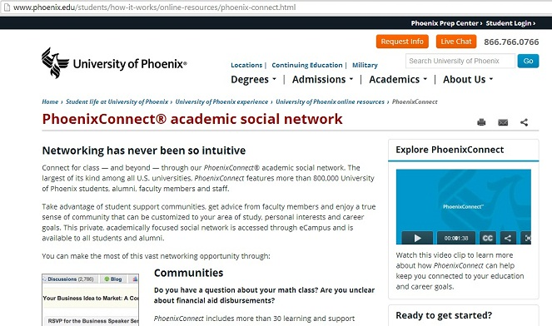
- Phoenix Connect - academic social network [8]
Some universities join their efforts with professional software companies and create specific web sites for students’ networking [9].
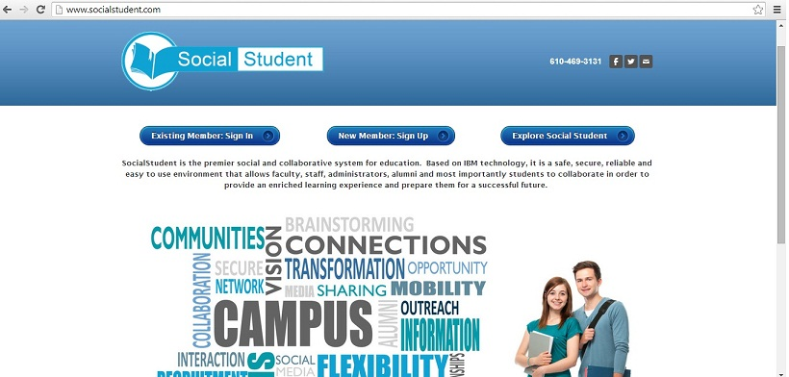
- Social student website [8]
Alumni tools are usually incorporated within web sites of other more general social network web applications, such as LinkedIn Alumni [10]. Some companies offer of-the-shelf software solutions to be used for alumni record [11].
This paper presents results in research about alumni web applications, as well as to present developed solution for alumni records as an additional part of current web site of Technical Faculty “Mihajlo Pupin” Zrenjanin, University of Novi Sad.

Alumni tools and benefits
Alumni software tools enable variety of functionality. Some common features of these tools enable [12]: personal career presentations, group making, marketing, events organizations, job search etc.

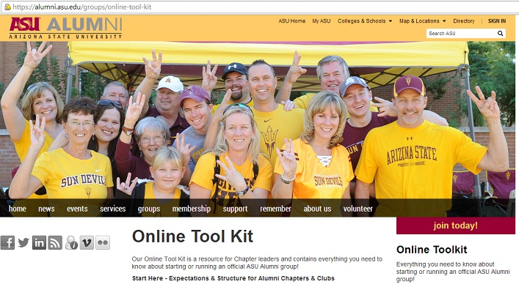

- Arizona University Alumni - online toolkit [12]
Alumni connections among former students represents powerful social capital. There are many ways that higher education institution could provide benefits to alumni members, such as [13]:
- Helping Alumni Find Jobs
- Meeting Alumni Where They're At
- Providing Tools To Spread Information
- Alumni-Generated Content – sharing files and photos
- Promoting Alumni Networks
- Mobile Reunions
- Training Alumni To Use Social Media
Educational institutions could also benefit from alumni web sites, such as [13]:
- Collaboration and Connecting With Students
- Fundraising: donations to school
Alumni community could also be beneficial for University School’s marketing [14]. “From a marketing perspective, former students should be a solid plank in your marketing plan. Your alumni are your most treasured and hard won assets. They can speak on your behalf in high places, they can spread the message about your school into areas you could never reach, they can correct a wrong impression and they can direct people and resources your way. Finally, they have the potential to mature into benefactors. But having alumni advocates does not happen by chance. Your former students must be nurtured and cultivated. They must feel a part of the school community. Here are some ways to develop long-term loyalty in your present students and draw former students into the school and keep the old school spirit alive.” [14]
Additional tools within alumni pages enable statistics, i.e. data analysis in aim to promote careers of the alumni members. One such tool for data analysis is integrated within LinkedIn Alumni pages [15]. One such example of data analysis result for University of Novi Sad alumni within particular LinkedIn user page is presented at Figure 4.

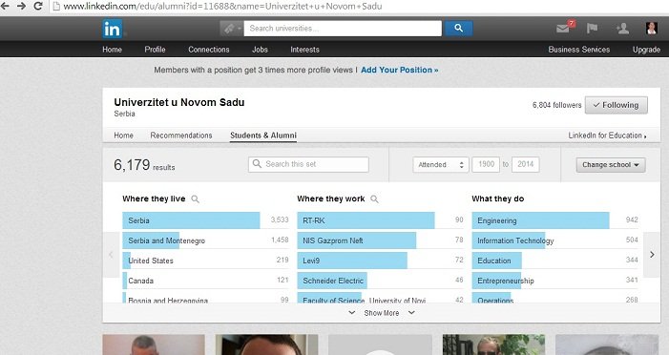

- LinkedIn Alumni statistics

Development of Alumni @ TFZR website
Development of alumni pages within web site of Technical Faculty “Mihajlo Pupin” Zrenjanin, University of Novi Sad was motivated as contribution to 40 years anniversary celebration preparations. This year was 40 years anniversary of this higher education institution foundation.
The project “Alumni web support at official web page of Technical faculty ‘Mihajlo Pupin’ Zrenjanin, University of Novi Sad” (shortly: Alumni@TFZR”) was implemented within several phases and activities:
- Data collection about alumni members – the list of all graduates at Bachelor, Master and PhD studies was collected from Students’ administration office
- Data collection about alumni member careers – by personal contacts via e-mail, using social networks such as LinkedIn and Facebook, the initiative for alumni web pages creation and data collection was promoting and all the collected data were sent to the project manager.
- Creating alumni promotion document as static document (PDF) with photos, short professional biographies and short motivating sentences aimed for future students about alumni member’s experiences at the educational institution.
- Creating static web page with list of graduates (Figure 5.), link to promotion document and detailed representation – after choosing “Biografija” link (Figure 6.) of one alumni representative for each study programme (Figure 7.).

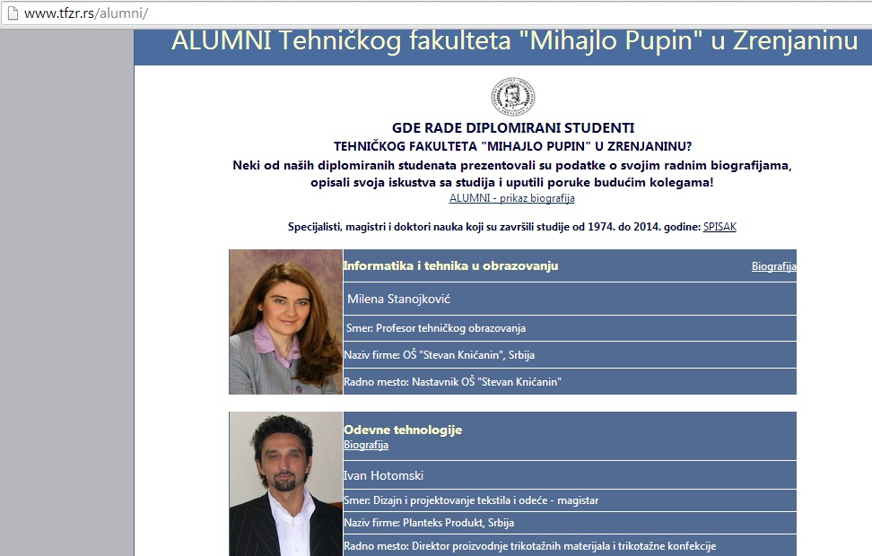
- Static web page of Alumni @ TFZR
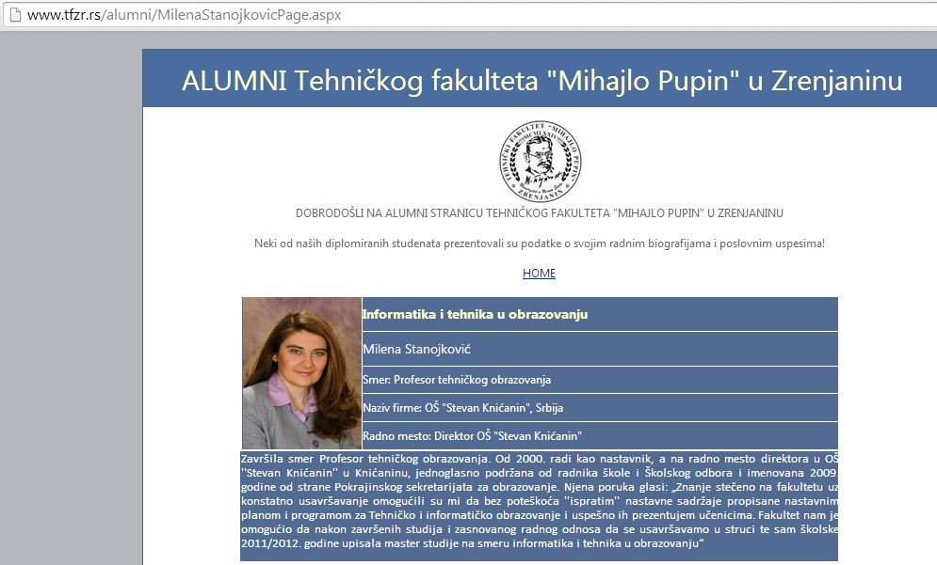
- Details about one of alumni representative within Alumni@TFZR
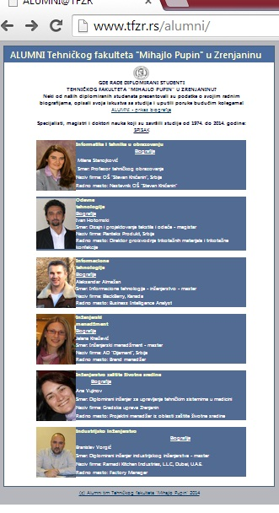
- List of each study programme alumni representatives at alumni@TFZR

Final phase is creating dynamic web page with database support to registration of alumni members, administration of alumni data and public presentation of verified alumni data. The final “dynamic” version of this web application is planned to be installed in july 2014.

IMPLEMENTATION OF DYNAMIC ALUMNI@TFZR
In this section the development process and implemented elements of dynamic web application for alumni records within Alumni@TFZR will be presented. Dynamic web application is developed as simple support to representation of alumni members biographies. The process of development of dynamic application was organized within several phases of activities:
1. Determination of user types (actors) and use case design:
- unregistered web site visitor could use functions: list of alumni members and detailed description presentation
- alumni member could do registration (adding short biography and message to future students, upload photo) as presented at Figure 8.
- administrator could log in and perform verification of alumni data, so they could be presented in public, as presented at Figure 9.
2. Database design – two (not related) data tables are created within MS SQL Server. First table includes data about administrator, in aim to enable administrator login. Second table includes data for alumni registration, personal and professional data, as well as status of alumni data (such as “non-verified” , “rejected” , “verified”).
3. Design of user interface – web application is created within Visual Studio .NET development environment, as ASPX application. New pages are added for input, edit and data retrieval. Existing pages from static version of website were changed to enable data retrieval from database.

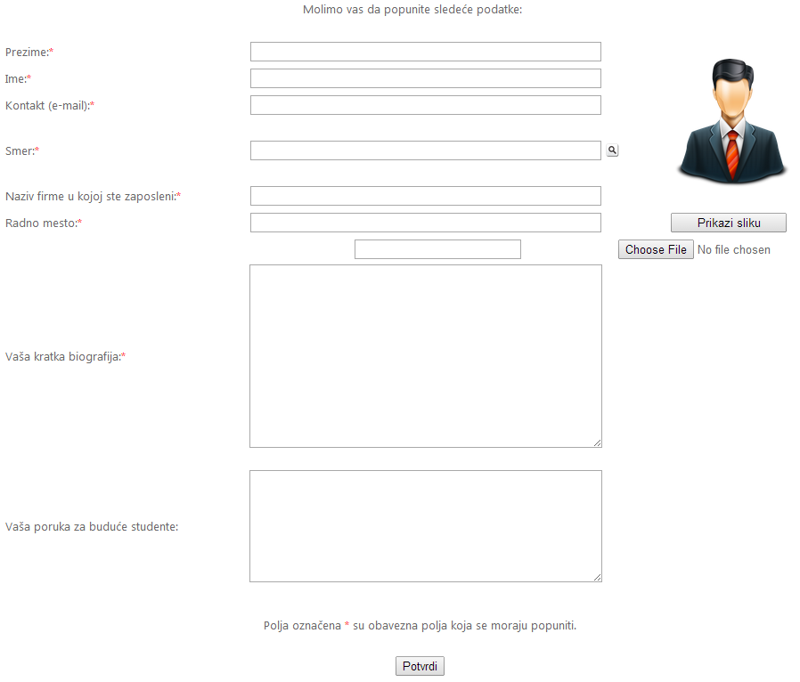
- Alumni registration within Alumni@TFZR
4. Programming - connection to database and all operations with data – input (in alumni registration), edit (in data verification) and retrieval (in tabular representation of all verified alumni data) is made by using C# programming language. In personalized data verification (i.e. after administrator successfully log in), sessions are used to enable secure administration.
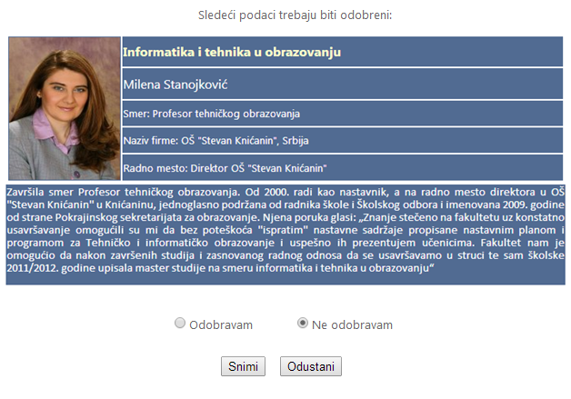
- Verification of alumni data by administrator
Finally, the main page (default.aspx) that includes list of all verified alumni data is changed so it presents data from database.

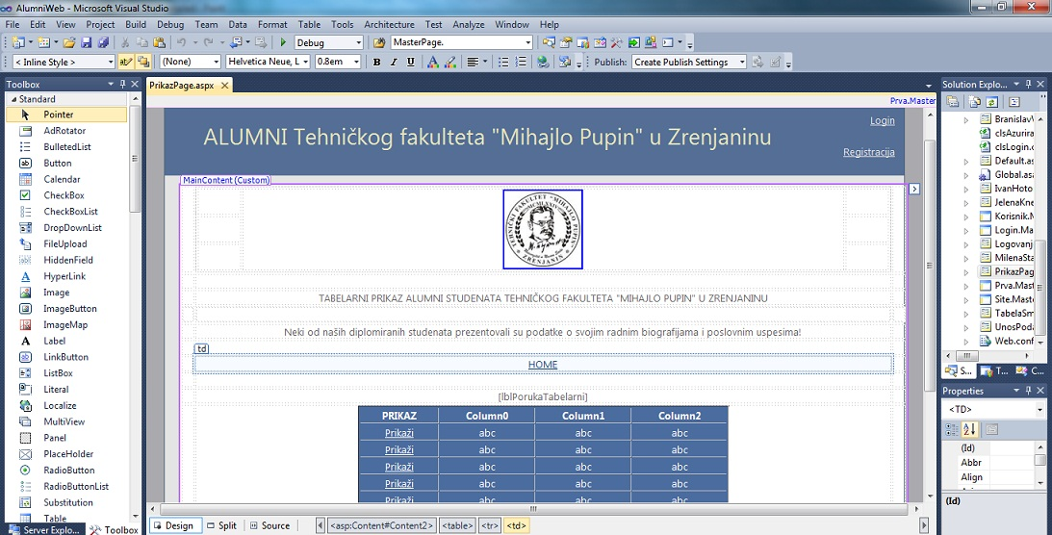
- List of verified data in main page, presented within development environment

Conclusion
Alumni web applications are usually parts of generally accepted and popular social networking web applications or parts of educational institutions web sites. Alumni tools enable benefits for alumni members, such as personal and professional connections, job search aid and cooperation support. Obviously, educational institutions benefit in marketing of institution, by promoting alumni member careers and their professional achievements.
Within 40 year anniversary celebration of Technical faculty “Mihajlo Pupin” in Zrenjanin (University of Novi Sad) foundation, an initiative for enhancement of existing institutional web site with alumni pages resulted first in static pages with alumni data, but it also evolved in dynamic version based on database support.
Future plans for the Alumni@TFZR software includes improvement in personalization for each alumni member, automated data verification and enhancements in adding social networking tools features.

References

- T. E. Seeman, “Social ties and health: The benefits of social integration”, Annals of Epidemiology, Volume 6, Issue 5, Pages 442-451, September 1996.
- www.facebook.com
- Top 18 social networking for teachers, http://www.educatorstechnology.com/2012/12/social-networking-sites-teachers.html
- Top 20 social networks for education, http://cyber-kap.blogspot.com/2011/08/top-20-social-networks-for-education.html
- www.linkedin.com
- A. Enders, H. Hungenberg, H.-P. Denker and S. Mauch, “The long tail of social networking. Revenue models of social networking sites”, European Management Journal (2008) 26, 199–211.
- M. M. Skeels and J. Grudin, “When Social Networks Cross Boundaries: A Case Study of Workplace Use of Facebook and LinkedIn”, ACM, GROUP’09, May 10–13, 2009, Sanibel Island, Florida, USA.

- University of Phoenix, socual academic network, http://www.phoenix.edu/students/how-it-works/online-resources/phoenix-connect.html
- www.socialstudent.com
- LinkedIn Alumni
- Alumni Tool – professional software, https://www.symplicity.com/alumnicommunity_core_features#mba-directory
- Arizona State University Alumni Online Toolkit, https://alumni.asu.edu/groups/online-tool-kit
- V. Lavrusik, “10 Ways Universities Are Engaging Alumni Using Social Media”, http://mashable.com/2009/07/23/alumni-social-media/
- School Alumni as Advocates, http://www.centreformarketingschools.com.au/free-marketing-articles/school-alumni-as-advocates
- LinkedIn Alumni pages, www.linkedin.com/alumni

